**NLPL**

**Business Requirement**



**Project Name: NLPL SAPB1 CR**

**Client Name: NLPL**

**Client Background**:

Nepal Liquors Pvt Ltd (NLPL) previously known as United Spirits Nepal Pvt Ltd (USNPL) was a subsidiary of the Indian liquors giant United Spirits Limited (USL), which in turn is a subsidiary of Diageo Plc. After acquisition only the name of the company has been changed. Its marketing strategies, plans and products, which have been on the market for the past four decades, remains the same. NLPL has one manufacturing unit in Biratnagar to manufacture and distributes alcoholic beverages across the country. It has altogether eight regional distributors and 70 sub-distributors.

Nepal Liquor Pvt Ltd is an existing SAP Business One user since 2009. The current business process requires a level of customization in their current A/R invoice generation due to their altered discounting practice where the taxes are included on the complete invoice and is not affected by the discount given to customer.

1. **Different Document Numbering Series for HO and Factory (A/P Invoice, Outgoing Payments and Purchase Order)**
2. **Backdated entries to be blocked except specified finance users**
3. **Discount Setup Screen:**

A discount configuration screen needs to be designed to enable user to manually change the discount per case and add new items along with discount per case amount.

The discount screen will have three mandatory and editable fields as follow:

1. Item Code
2. Item Description/Name
3. Per Case Discount

Expected feature:

* Item Code should be linked to the item master.
* Item Code should be a searchable field can be searched from the item master
* Item description field should auto fill upon selection of respective item code

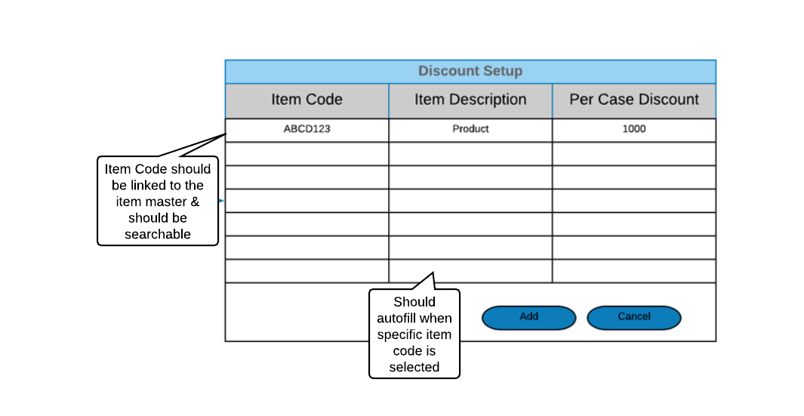

1. **A/R Invoice:**

The A/R invoice will have the existing layout with 4 additional fields. The item level rows will have two additional fields or columns:

1. Per Case Discount
2. Discount Value (Per Case Discount x No of case)

The invoice should also have two overall additional fields which would be:

1. Discount Journal Entry
2. Total Discount On all the items.

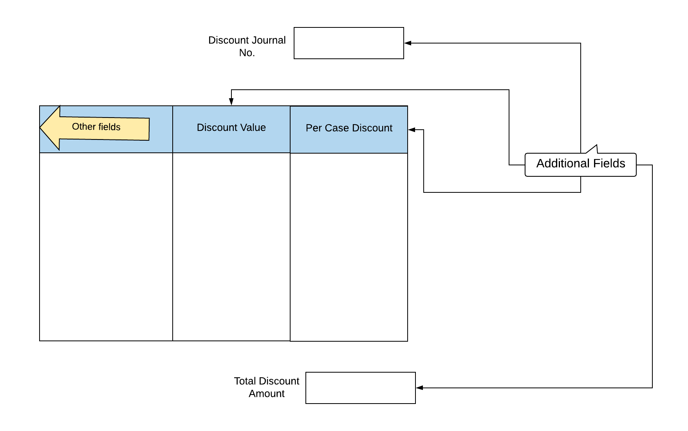

**Journal Entry:**

The journal entry process for NLPL A/R invoice differs from the usual practice. The automatic journal entry for an A/R invoice should not account for the discounted amount as even the discounted amount is taxed. Hence, the journal entry should be of the complete amount including the discounted amount.

The discount needs to be adjusted in a separate journal entry where the discounted amount should be debited to Discount Ledger and credited to the customer. This journal entry number should be displayed in the invoice. This discounted journal entry should be accessible from the invoice.

This journal entry should be created automatically upon creating a A/R invoice.

The discounted journal entry should have the invoice number and the customer name as remarks.

Provision for having the discount account name in the discount setup screen can also be made.

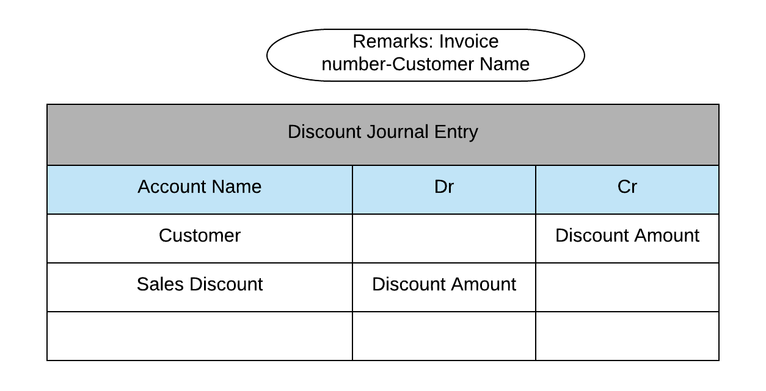

1. **Validation for production receipt and issue:**

In the current scenario, users while creating a production issue and receipt are able to change the preset quantity for each product. This is resulting in users entering excess or less quantity than the planned quantity hindering the production plan

Solution:

NLPL wants to validate the quantity to be entered in the production issue and receipt. A tolerance level will be set in percentage and hence will be used to validate the entered quantity. The user should not be allowed to create a production issue or receipt with the quantity being within the given tolerance level. This tolerance level has to be configurable.

Expected Functionality:

* Validation for the entered quantity in production issue/receipt
* Tolerance level for each item which can be configured
* Popup/Alert upon entering the quantity below or beyond the tolerance level

1. **New GRPO Layout:**

In the current purchase process, the generated GRPO is printed on a Dot-Matrix printer and hence NLPL has planned to change the printing device requiring a change in the GRPO layout.

The current layout for GRPO has been shown below:

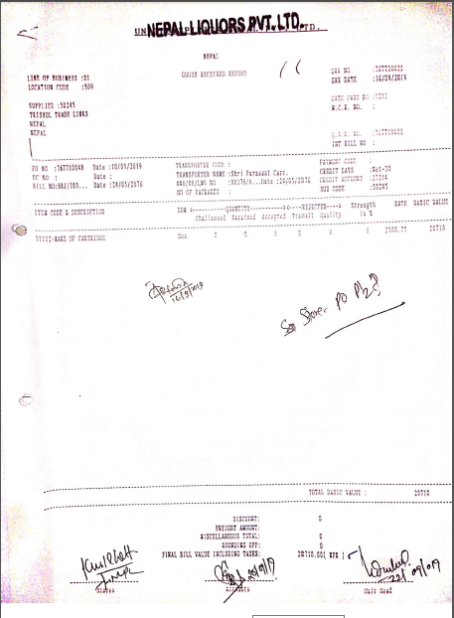

Proposed Layout:

The GRPO will have a Standard SAP Business One Layout provided by IT Nepal with the agreed upon entries. The new GRPO will be identical to the existing GRPO with the same entries and fields but with a new print layout.

1. **Vendor GL Report:**

The vendor GL Report should include the following:

* Total purchase amount
* Taxable amount
* Tax Amount
* TDS amount
* TDS Ledger

1. **Business Partner Aging Report:**

NLPL requires a business partner aging report giving an overview of the pending vendor and customer payments. The report should indicate the currently pending outgoing and incoming payments and their aging.

Solution:

This reports can be generated through SAP standard Vendor/Customer Aging Report. SAP Business One has the provision to generate a report called Vendor Liability Aging Report which align with NLPL’s requirement. Hence, implementation of this report should suffice NLPL’s requirement of a business partner aging report.

An example of the Vendor Liability Aging Report is shown below:

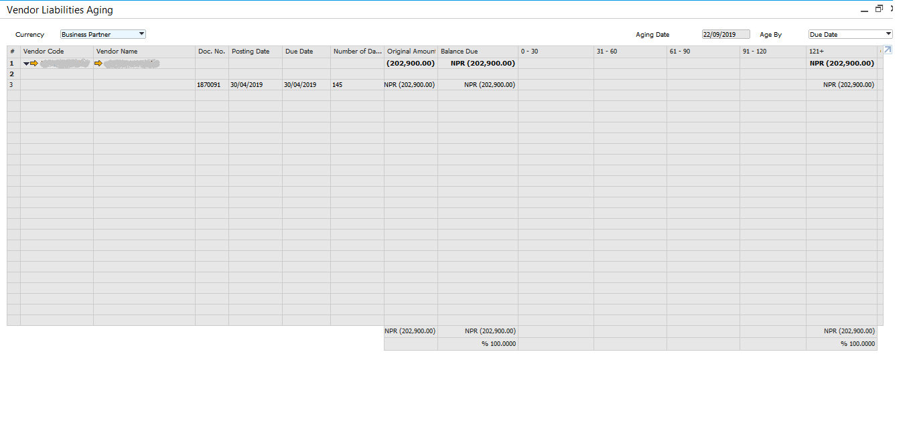

As shown above the payables are categorized according to aging. The payments are differentiated as 0-30, 31-60,61-90,91-120 and 120+ days after the payment due date.

1. **Inventory Aging Report:**

NLPL’s requirement is to implement an inventory aging report. This report should indicate the aging of the stock based on the Date of Purchase or the Date on the GRPO. The inventory aging report should give the quantity of the goods based on the age of stock since purchase.

Solution:

SAP does not provide a standard Inventory Aging Report. Hence, a customized inventory aging report would be created which will have the following fields:

* Item Code
* Description
* GRPO Number
* GRPO Date
* In Stock (qty)
* In Stock Value
* 0-30 Days (qty)
* 0-30 Days (Value)
* 31-60 Days (qty)
* 31-60 Days (Value)
* 61-90 Days (qty)
* 61-90 Days (Value)
* 91-120 Days (qty)
* 91-120 Days (Value)
* 120 Days + (qty)
* 120 Days + (Value)

